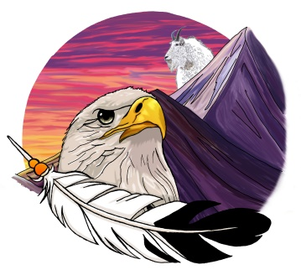
Upper Similkameen Indian Band
Aboriginal Day & Education Celebration
June 21, 2022
Registration Form

(One registrant form for each adult, Parents or Guardians can sign waiver for Minors on this form)
Registration for: □ Adult □ Child (Under 18 Years) □ Elder

Registration Contact:
Name: Email:
Address: Phone Number
City: Prov: Zip code:

Registrants:
Name Age Hoodie Size (Unisex Xsm, SM,MED, Lrg, ex-lrg, 2x, 3x)
1.
2.
3.
4.
5.

Emergency Contact:
Name: Phone Number:
Cell:

Waiver:
1. I understand and agree that USIB accepts no responsibility for my acts or the acts of others while participating in and travelling in connection with the USIB Aboriginal Day & Education Celebration.
2. I agree to observe and obey all verbal, written and posted rules and warnings given by the USIB staff.
3. I hereby release, relieve, discharge and hold harmless USIB and its staff, trustees and representatives from all liability, whether personal injury or loss, damage, or otherwise arising out of connection with participating in the Aboriginal Day & Education Celebration
4. I agree to indemnify and defend USIB against all claims, cause of action, damages, judgment, loss or expenses including attorney fees and other litigation costs, which may arise.
5. I agree to pay for all damages to facilities or property caused by my family’s negligent, reckless or willful actions.
6. In the event of injury during the Aboriginal Day & Education Celebration do hereby give my consent to the Upper Similkameen Indian Band to secure and authorize such emergency medical treatment as the above name might require while on the Aboriginal Day & Education Celebration hosted by the Upper Similkameen Indian Band. I also agree to pay all the costs and fees contingent on emergency medical care or treatment for this person as secured or authorized under this consent.
7. I will also refrain from drinking alcohol or taking drugs (non-prescription) throughout the duration of this event. If found using either of the substances, I understand that I will be asked to leave at any time.

By signing below, I acknowledge that I have read and understand the Release of Liability. I further understand that by signing this release, I voluntarily surrender certain legal rights.
I also give the Upper Similkameen Indian Band permission to photograph and release all photos of me during this event. I am aware that photos and filming will take place and may be distributed and/or posted on the Upper Similkameen Indian Band website.

Print Applicant’s Name: Date:

Signature:

***Return signed, completed registration form to educ@usib.ca or sally.holmes@usib.ca or drop off at administration office. ***

